Day 12 — Cache and Persist

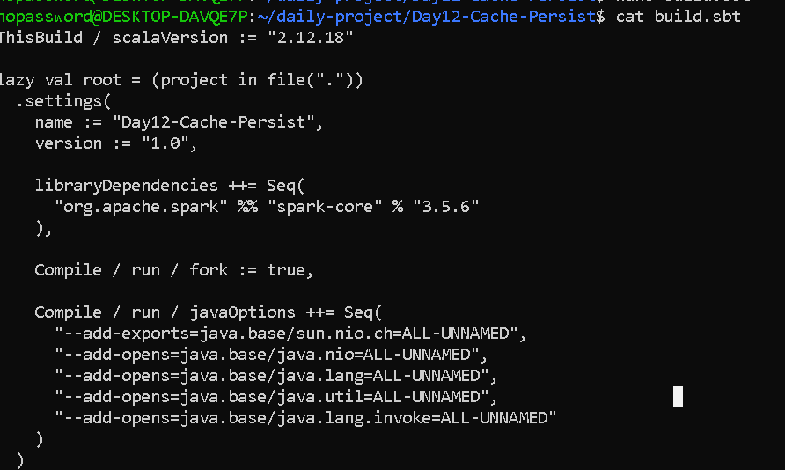

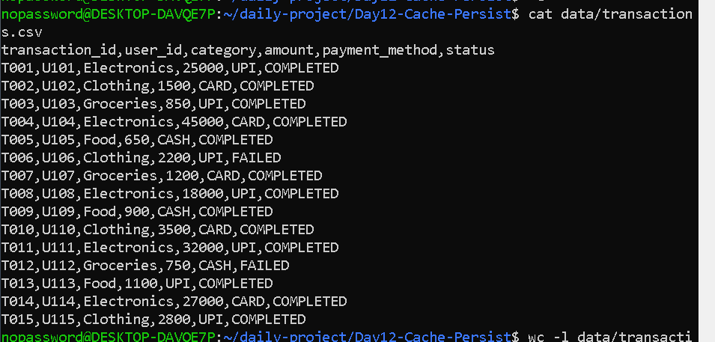

nopassword@DESKTOP-DAVQE7P:~/daily-project/Day12-Cache-Persist$ cat src/main/scala/D
ay12CachePersist.scala
import org.apache.spark.{SparkConf, SparkContext}
import org.apache.spark.storage.StorageLevel

object Day12CachePersist {

def main(args: Array[String]): Unit = {

val conf = new SparkConf()
.setAppName("Day12 Cache and Persist")
.setMaster("local[*]")

val sc = new SparkContext(conf)

sc.setLogLevel("WARN")

println("======================================")
println("DAY 12 - CACHE AND PERSIST")
println("======================================")

// ------------------------------------------------
// STEP 1: Read transaction data
// ------------------------------------------------

val rawData = sc.textFile("data/transactions.csv")

val header = rawData.first()

val transactions = rawData
.filter(line => line != header)
.map(_.split(","))

println("\nTotal raw transaction records: " + transactions.count())

// ------------------------------------------------
// STEP 2: Clean transaction data
// ------------------------------------------------

val cleanedTransactions = transactions
.filter(fields => fields.length == 6)
.filter(fields => fields(5) == "COMPLETED")
.map(fields => (
fields(0),
fields(1),
fields(2),
fields(3).toDouble,
fields(4),
fields(5)
))

// ------------------------------------------------
// STEP 3: Cache the cleaned RDD
// ------------------------------------------------

cleanedTransactions.cache()

println("\nCleaned transaction count: " +
cleanedTransactions.count())

println("Cleaned transaction RDD has been cached.")

// ------------------------------------------------
// REPORT 1:
// Total transaction amount by category
// ------------------------------------------------

println("\n========== REPORT 1 ==========")
println("Total Amount by Category")

val categoryTotals = cleanedTransactions
.map(transaction => (transaction._3, transaction._4))
.reduceByKey(_ + _)

categoryTotals.collect()
.sortBy(_._1)
.foreach {
case (category, total) =>
println(category + " -> Rs." + total)
}

// ------------------------------------------------
// REPORT 2:
// Transaction count by payment method
// ------------------------------------------------

println("\n========== REPORT 2 ==========")
println("Transactions by Payment Method")

val paymentCounts = cleanedTransactions
.map(transaction => (transaction._5, 1))
.reduceByKey(_ + _)

paymentCounts.collect()
.sortBy(_._1)
.foreach {
case (method, count) =>
println(method + " -> " + count + " transactions")
}

// ------------------------------------------------
// REPORT 3:
// High-value transactions
// ------------------------------------------------

println("\n========== REPORT 3 ==========")
println("High Value Transactions (> Rs.20,000)")

val highValueTransactions = cleanedTransactions
.filter(transaction => transaction._4 > 20000)

highValueTransactions.collect()
.foreach {
transaction =>
println(
transaction._1 +
" -> " +
transaction._3 +
" -> Rs." +
transaction._4
)
}

// ------------------------------------------------
// STEP 4: Persist with MEMORY_ONLY
// ------------------------------------------------

println("\n========== PERSIST TEST ==========")

cleanedTransactions.unpersist()

cleanedTransactions.persist(StorageLevel.MEMORY_ONLY)

println("Storage level: " +
cleanedTransactions.getStorageLevel)

println("Persisted record count: " +
cleanedTransactions.count())

// ------------------------------------------------
// STEP 5: Change storage level
// ------------------------------------------------

cleanedTransactions.unpersist()

cleanedTransactions.persist(StorageLevel.MEMORY_AND_DISK)

println("\nChanged storage level to:")
println(cleanedTransactions.getStorageLevel)

println("Persisted record count: " +
cleanedTransactions.count())

// ------------------------------------------------
// STEP 6: Remove RDD from cache
// ------------------------------------------------

cleanedTransactions.unpersist()

println("\nRDD has been removed from cache.")

println("\n======================================")
println("DAY 12 COMPLETED")
println("======================================")

sc.stop()
}
}

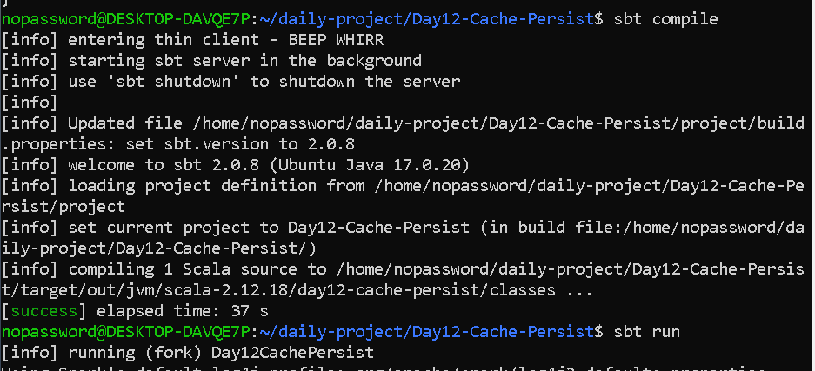

OUTPUT—

